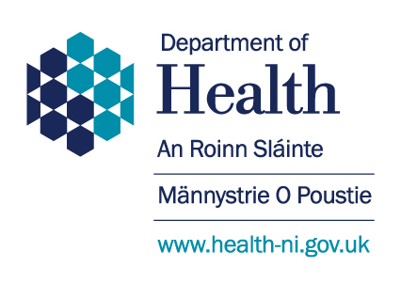

Improving Neurology Care in NI
Pathways for Long Term Conditions Workshop – 2nd and 3rd April 2020

The Department of Health is hosting two workshops to inform the development of care pathways for people with long term neurological conditions. Pathways are being developed as part of the Regional Review of Neurology Services which is considering how neurology services can be improved and become more effective over the next 10-15 years.
Pathways are being developed for:
- Multiple Sclerosis;
- Parkinson’s disease and hyperkinetic disorders;
- Epilepsy;
- Huntingtons disease and rare disorders;
- Neuromuscular disorders and Motor Neurone Disease
- Functional Neurological Disorders

We want your views to play a central role in helping shape these Pathways.

The workshops will run from 10.30am – 12.30pm at the following venues:
- Thursday 2nd April – Silverbirch Hotel, Omagh;
- Friday 3rd April – Mossley Mill, Newtownabbey

The Department of Health is committed to a coproduction approach to the Regional Review. We hope that you will considering joining us to share your views. If you would like to participate, please contact us at Neurology.Review@health-ni.gov.uk or telephone 028 9076 5643.

