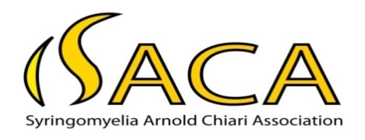

Registered with The Charity Commission for NI NIC100528
HM Revenue and Customs No. XT6688

Phone: 078 26 004 008 (Helpline) E-mail:info@saca.org.uk

29th Annual General Meeting Notice

Saturday 19th October 2019 at 4.00 pm – 6.30 pm
Rotunda Suite, Hastings Europa Hotel, Great Victoria St, Belfast BT2 7AP

Programme:

4.00 pm Welcome

4.05 pm Dr Pamela Bell, Chair, Pain Alliance NI on ‘Coping with Pain’

4.45pm Refreshments (Please let us know if you have any special dietary requirements)

Time to mingle, chat and renew your Membership Fees

5.30pm Annual General Meeting

- Annual Report 2. Minutes of 2018 AGM 3. Treasurer’s Report
- Election of Officers 5. 50% Fund 6. Any other business

If you are planning to attend please contact our Helpline on 078 26 004 008
or email us on: info@saca.org.uk

This is a free event and all are welcome. Please bring along a prize for the raffle.

Paid up members can avail of the SACA Travel Fund which will also assist members with city centre car parking charges for this event.

